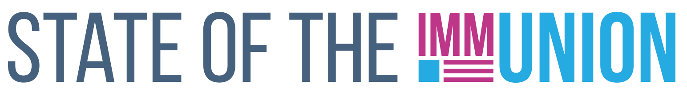

**2023**

**North Carolina**

**Kindergarten Vaccination Rates**

***Select vaccination rates for kindergarteners in North Carolina:***

* Measles: 95.2%
* Varicella (chickenpox): 95.1%
* Polio: 95.2%

**Early Childhood Vaccination Rates**

***Select vaccination rates for children 0-35 months in North Carolina:***

* Measles: 97.3%
* DTaP (whooping cough): 99.7%
* Polio: 95.0%

State and local health departments can use Section 317 funds for a number of immunization-related activities, including providing vaccines for uninsured adults, staffing clinics, and carrying out education and outreach campaigns. In FY22, North Carolina received $8,544,770 in Section 317 funds.

*For more information, contact INSERT CONTACT INFO HERE*

**FULLY FUNDING THE SECTION 317 IMMUNIZATION PROGRAM IS THE BEST WAY TO ENSURE THAT EVERYONE WHO WANTS A VACCINE CAN GET ONE**

**Adult Vaccination Rates**

***Select vaccination rates for adults in North Carolina:***

* Flu: 49.3%
* COVID-19: 82.6%
* Pneumococcal (65+): 75.2%
* Shingles (50+): 43.6%

**Adolescent Vaccination Rates**

***Select vaccination rates for teens 13-17 in North Carolina:***

* Measles: 95.3%
* Varicella (chickenpox): 92.5%
* HPV: 67.8%

Insert your logo here