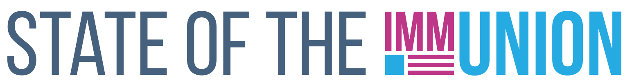

**2023**

**North Dakota**

**Kindergarten Vaccination Rates**

***Select vaccination rates for kindergarteners in North Dakota:***

* Measles: 93.3%
* Varicella (chickenpox): 93.2%
* Polio: 93.2%

**Early Childhood Vaccination Rates**

***Select vaccination rates for children 0-35 months in North Dakota:***

* Measles: 93.1%
* DTaP (whooping cough): 88.4%
* Polio: 96.4%

State and local health departments can use Section 317 funds for a number of immunization-related activities, including providing vaccines for uninsured adults, staffing clinics, and carrying out education and outreach campaigns. In FY22, North Dakota received $1,101,185 in Section 317 funds.

*For more information, contact INSERT CONTACT INFO HERE*

**FULLY FUNDING THE SECTION 317 IMMUNIZATION PROGRAM IS THE BEST WAY TO ENSURE THAT EVERYONE WHO WANTS A VACCINE CAN GET ONE**

**Adult Vaccination Rates**

***Select vaccination rates for adults in North Dakota:***

* Flu: 51.1%
* COVID-19: 74.8%
* Pneumococcal (65+): 70.4%
* Shingles (50+): 53.2%

**Adolescent Vaccination Rates**

***Select vaccination rates for teens 13-17 in North Dakota:***

* Measles: 98.3%
* Varicella (chickenpox): 94.9%
* HPV: 72.2%

Insert your logo here