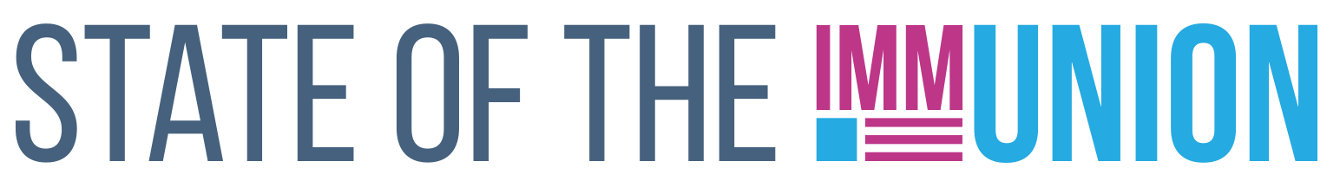

**2023**

**Rhode Island**

**Kindergarten Vaccination Rates**

***Select vaccination rates for kindergarteners in Rhode Island:***

* Measles: 97.0%
* Varicella (chickenpox): 96.7%
* Polio: 96.9%

**Early Childhood Vaccination Rates**

***Select vaccination rates for children 0-35 months in Rhode Island:***

* Measles: 97.6%
* DTaP (whooping cough): 98.7%
* Polio: 99.5%

State and local health departments can use Section 317 funds for a number of immunization-related activities, including providing vaccines for uninsured adults, staffing clinics, and carrying out education and outreach campaigns. In FY22, Rhode Island received $1,265,671 in Section 317 funds.

*For more information, contact INSERT CONTACT INFO HERE*

**FULLY FUNDING THE SECTION 317 IMMUNIZATION PROGRAM IS THE BEST WAY TO ENSURE THAT EVERYONE WHO WANTS A VACCINE CAN GET ONE**

**Adult Vaccination Rates**

***Select vaccination rates for adults in Rhode Island:***

* Flu: 64.4%
* COVID-19: 96.7%
* Pneumococcal (65+): 74.6%
* Shingles (50+): 43.6%

**Adolescent Vaccination Rates**

***Select vaccination rates for teens 13-17 in Rhode Island:***

* Measles: 94.8%
* Varicella (chickenpox): 94.5%
* HPV: 83.2%

Insert your logo here