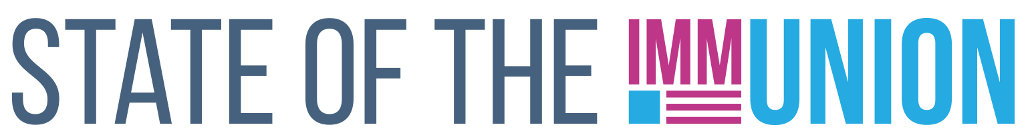

**2023**

**South Carolina**

**Kindergarten Vaccination Rates**

***Select vaccination rates for kindergarteners in South Carolina:***

* Measles: 94.4%
* Varicella (chickenpox): 94.2%
* Polio: 95.3%

**Early Childhood Vaccination Rates**

***Select vaccination rates for children 0-35 months in South Carolina:***

* Measles: 96.8%
* DTaP (whooping cough): 92.8%
* Polio: 94.3%

State and local health departments can use Section 317 funds for a number of immunization-related activities, including providing vaccines for uninsured adults, staffing clinics, and carrying out education and outreach campaigns. In FY22, South Carolina received $3,706,429 in Section 317 funds.

*For more information, contact INSERT CONTACT INFO HERE*

**FULLY FUNDING THE SECTION 317 IMMUNIZATION PROGRAM IS THE BEST WAY TO ENSURE THAT EVERYONE WHO WANTS A VACCINE CAN GET ONE**

**Adult Vaccination Rates**

***Select vaccination rates for adults in South Carolina:***

* Flu: 47.5%
* COVID-19: 79.6%
* Pneumococcal (65+): 70.9%
* Shingles (50+): 37.9%

**Adolescent Vaccination Rates**

***Select vaccination rates for teens 13-17 in South Carolina:***

* Measles: 95.3%
* Varicella (chickenpox): 95.2%
* HPV: 62.1%

Insert your logo here