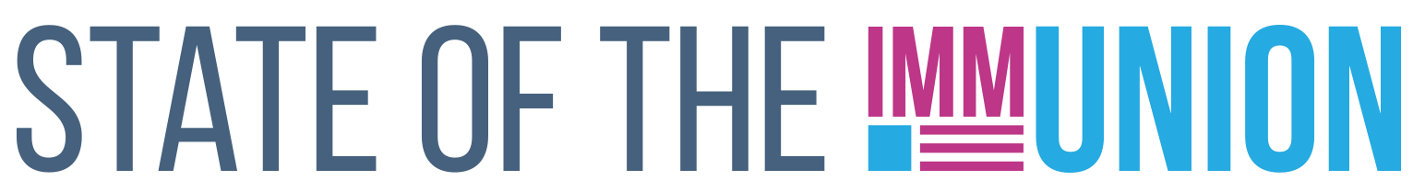

**2023**

**South Dakota**

**Kindergarten Vaccination Rates**

***Select vaccination rates for kindergarteners in South Dakota:***

* Measles: 94.6%
* Varicella (chickenpox): 94.0%
* Polio: 94.5%

**Early Childhood Vaccination Rates**

***Select vaccination rates for children 0-35 months in South Dakota:***

* Measles: 96.0%
* DTaP (whooping cough): 77.5%
* Polio: 93.6%

State and local health departments can use Section 317 funds for a number of immunization-related activities, including providing vaccines for uninsured adults, staffing clinics, and carrying out education and outreach campaigns. In FY22, South Dakota received $1,434,923 in Section 317 funds.

*For more information, contact INSERT CONTACT INFO HERE*

**FULLY FUNDING THE SECTION 317 IMMUNIZATION PROGRAM IS THE BEST WAY TO ENSURE THAT EVERYONE WHO WANTS A VACCINE CAN GET ONE**

**Adult Vaccination Rates**

***Select vaccination rates for adults in South Dakota:***

* Flu: 54.2%
* COVID-19: 78.3%
* Pneumococcal (65+): 74.2%
* Shingles (50+): 55.1%

**Adolescent Vaccination Rates**

***Select vaccination rates for teens 13-17 in South Dakota:***

* Measles: 98.0%
* Varicella (chickenpox): 98.0%
* HPV: 74.7%

Insert your logo here